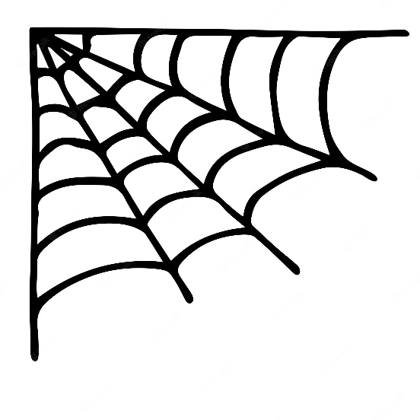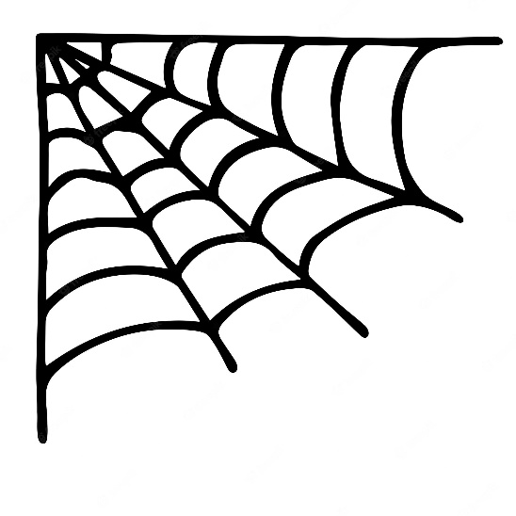**SUNBURY FIRE POLICE**

**HALLOWEEN PARADE**

*TO PROTECT AND SERVE*

1031 Keller Street Sunbury, PA 17801

**ANNUAL HALLOWEEN PARADE OCTOBER 16, 2025**

**Entry Fees:**

**Businesses & Organizations $25.00**

**Political $50.00**

NO 4 WHEELERS, MINIBIKES OR MOTORIZED SKATEBOARDS ALLOWED DUE TO INSURANCE RESTRICTIONS. Only forward drilling in the line of march.

***Candy may be passed out NOT THROWN for the children’s safety.***

***Participation is strictly at your own risk. We are not responsible for any injury.***

Pre-registrations will be accepted until October 15th at 4:00pm. The parade with form behind the Shikellamy Highschool starting at 5pm on Thursday, October 16th. With 10th Street being blocked for the parade, you will need to take an alternate route to Walnut Street. A committee person will place you in the parade line up. Registration and sign in will be from 5:00pm to 6:30pm. Parade will start moving at 7:00pm.

**\*PRE- Registration is REQUIRED to be entered into judging for eligible cash prize\***

**\*NEW* UPON SUBMISSION OF APPLICATION, YOU WILL BE ISSUED A REGISTRATION NUMBER.**

**IT IS YOUR RESPONSIBILITY TO HAVE YOUR REGISTRATION NUMBER DISPLAYED ON THE PASSENGER SIDE OF YOUR FLOAT/VEHICLE.**

***\*\*\*\*\*\*\*\*\*\*\*\*\*\*\*\*\*\*\*\*\*\*\*\*\*\*\*\*\*\*\*\*\*\*\*\*\*\*\*\*\*\*\*\*\*\*\*\*\*\*\*\*\*\*\*\*\*\*\*\*\*\*\*\*\*\*\****

NAME of Organization or Business (if applicable) ______________________________________

Contact Name __________________________________Telephone_______________________

Address_______________________________________________________________________

Name on Check if a Winner _______________________ Email ___________________________

**CIRCLE UNIT YOU ARE REPRESENTING (ONLY 1):**

**Business Individual Organization Political**

ENTRY DESCRIPTION_____________________________________________________________

______________________________________________________________________________

______________________________________________________________________________

NUMBER OF PARTICIPANTS _____________________ Age Range_________________________

**Make Checks Payable to Sunbury Fire Police**

Mail all forms & payment to:

Attn: Robyn Garinger

City of Sunbury Mayor’s Office

225 Market Street

Sunbury, PA 17801