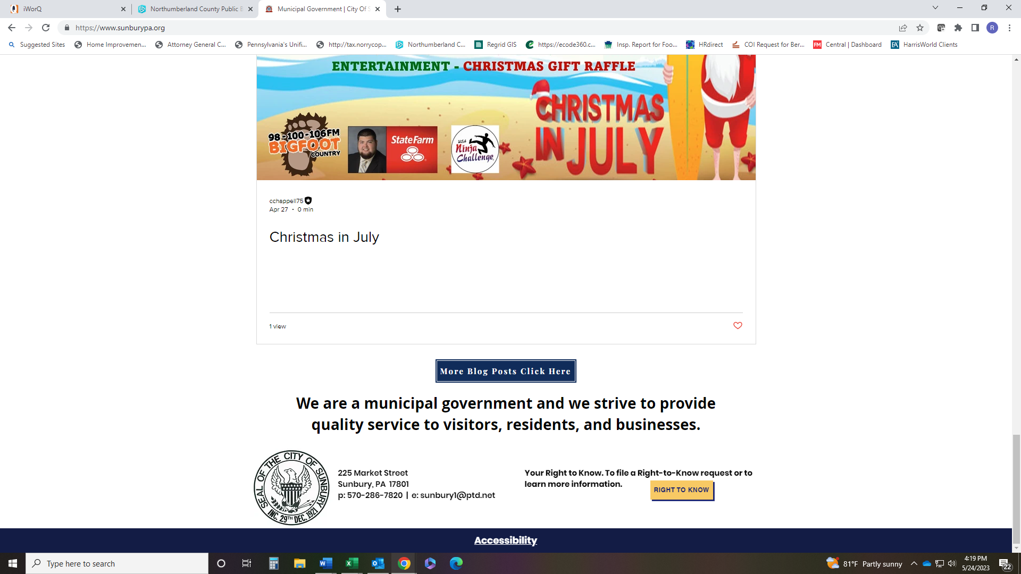
CITY OF SUNBURY
Office of Code Administration Permit No. _Z________
225 Market Street
Sunbury, PA 17801
(570) 286-4207
ZONING REVIEW PERMIT
LOCATION OF PROPERTY
Address: Tax Parcel No.:
Directions:
TYPE AND COST OF IMPROVEMENT
Type of Improvement  1 New Structure  2 Addition  3 Alteration  4 Repair, Replacement  5 Change of Occupancy/Zoning  6 Demolition/Excavation | Description: A concise, specific statement of proposed work or change. All new structures additions and alterations require (2) complete sets of scaled plans and specifications. Size and complexity of which may also require detailed information. Call Code Office for additional Information.
 | (Continue on back page) |  |  |  | Estimated Completion Date:
Declared cost (omit cents)  $_______________________ | Dimensions
 | Height in feet:_____________ |  |  | Combined square footage of
 | No. of Stories:_____________ |  |  | all floors (exterior dimensions):_________

IDENTIFICATION
Name |  | Complete Address | Phone
Owner
Architect/
Engineer
Contractor
Affidavit
I hereby that I am the owner in fee or the authorized agent of the owner in fee of the property upon which the work authorized by the permit sought will be performed. All work will be performed in accordance with all applicable laws and regulations of the United States of America, the Commonwealth of Pennsylvania, and the City of Sunbury.
Signature of owner or authorized agent |  | Address | Date
Affidavit (Building Energy Conservation Act)
I certify that I am the principle builder or the authorized agent of the principle builder of the work authorized by the permit sought. All work will be performed in accordance with all applicable laws of the United States of America, the Commonwealth of Pennsylvania and the City of Sunbury. In addition, I acknowledge that a warranty separate from all other contract documents and in specific writing indicating compliance with all the performance requirements of the Pennsylvania Building Energy Conservation Act (Act 222 of 1980) will be delivered by the Builder to the Owner, at the completion of the works.
Signature Of Builder |  | Address | Date
 |  |  | National Code Consultants

