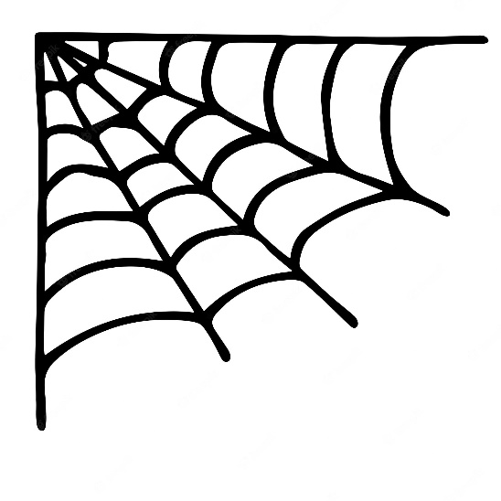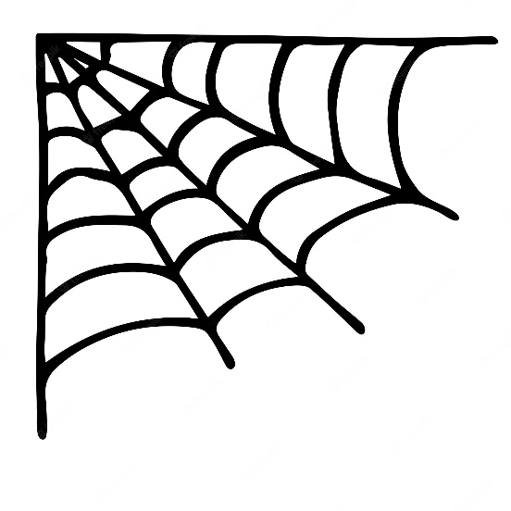SUNBURY FIRE POLICE

**HALLOWEEN PARADE**

*TO PROTECT AND SERVE*

1031 Keller Street Sunbury, PA 17801

ANNUAL HALLOWEEN PARADE OCTOBER 17, 2024

The parade will form behind the Shikellamy Highschool starting at 5pm. Registration and sign in is from 5pm to 6:30pm. Parade begins to move at 7pm The parade will end near the North 4th Street Plaza.

**Entry Fees:**

**Businesses, Individuals, & Organizations $25.00**

**Political $50.00**

NO 4 WHEELERS, MINIBIKES OR MOTORIZED SKATEBOARDS ALLOWED DUE TO INSURANCE RESTRICTIONS. Only forward drilling in the line of march.

***Candy may be passed out NOT THROWN for the children’s safety.***

***Participation is strictly at your own risk. We are not responsible for any injury.***

To be eligible for a cash prize, your entry must be registered. Registrations will close at 6:30pm night of parade Pre-Registration preferred. **Lineup will take place behind the high school. With 10th Street being blocked for the parade, you will need to take an alternate route to Walnut Street.** **A committee person will place you in the parade line up.**

**NOTE*PRE- Registration is REQUIRED to be ENTERED into JUDGING\***

***\*\*\*\*\*\*\*\*\*\*\*\*\*\*\*\*\*\*\*\*\*\*\*\*\*\*\*\*\*\*\*\*\*\*\*\*\*\*\*\*\*\*\*\*\*\*\*\*\*\*\*\*\*\*\*\*\*\*\*\*\*\*\*\*\*\*\****

NAME of Organization or Business (if applicable) ______________________________________

CONTACT NAME_________________________________Telephone_______________________

ADDRESS______________________________________________________________________

Name on Check if a Winner ______________________EMAIL: ___________________________

**CIRCLE UNIT YOU ARE REPRESENTING (ONLY 1):**

**Business Individual Organization Political**

ENTRY DESCRIPTION_____________________________________________________________

______________________________________________________________________________

______________________________________________________________________________

NUMBER OF PARTICIPANTS _____________________ Age Range_________________________

**Make Checks Payable to Sunbury Fire Police**

Mail all forms & payment to:

Attn: Robyn Garinger

City of Sunbury Mayor’s Office

225 Market Street

Sunbury, PA 17801